CEG 3131 – Computer Architecture II
Lab3 – Hardware Interfacing
Fall 2004

Names: | Student Numbers:
Daniel Shapiro | 2988887
Neelan Joachimpillai | 3103714

Objectives:
To interface the Motorola 68HC12 microcontroller with a keypad unit and
8 segment display unit.

PreLab:
Device setup
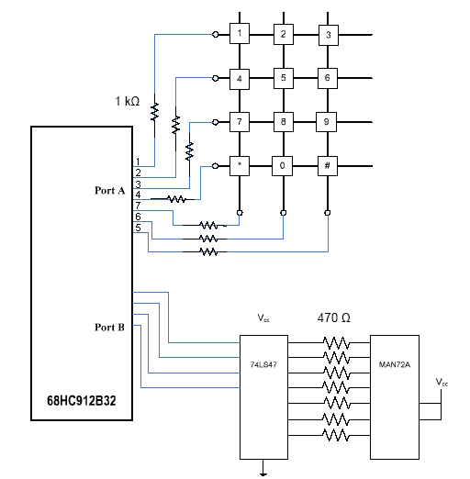

PART 1:
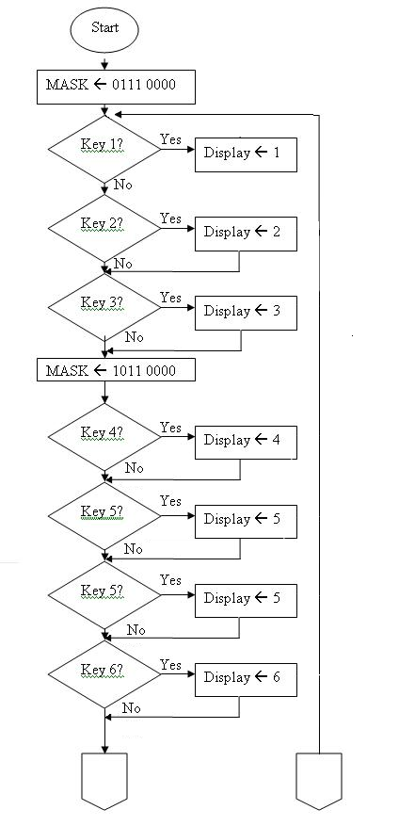
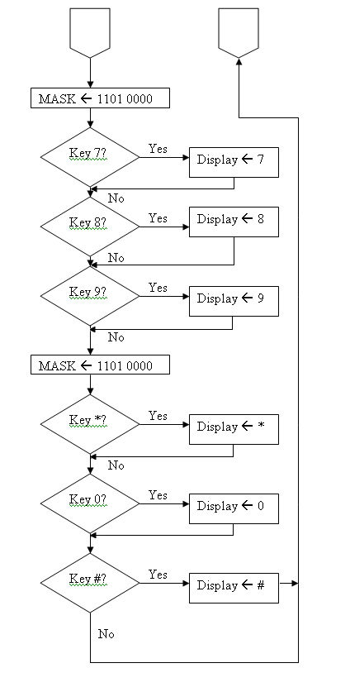

The program will iterate through the rows looking for a break in the voltage since the keypad is a pull-up keypad (meaning that the keypad has current flowing through it until the button is pushed). When a break is found, the number will be displayed, and then the search continues from the next key. Then after it has gotten to the last key, it will goto the first key This continues forever.

Part 2:

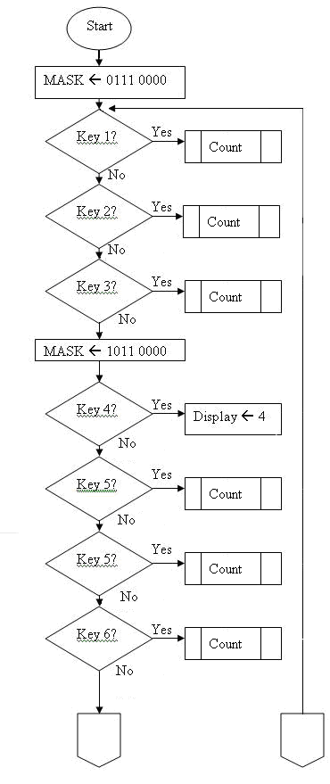
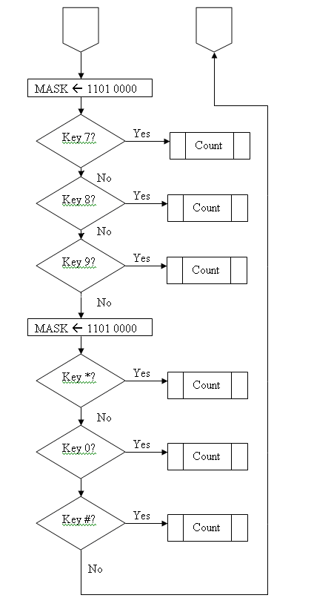

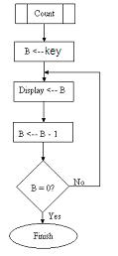

The flowchart will continue to iterate through the keys until a key is pressed. When a key is pressed, the count state will be entered. In the count state, the countdown will begin, with each number being displayed on the keypad for 1 second. When the number reached zero the program will end.

Equipment Used:
• Windows PC
• Evaluation board

Components Used:
• 1 only - TTL 74LS47 BCD-to-7 segment Decoder
• 1 only - 7-segment LED Display Unit – MAN72A
• 1 only keypad
• 1 only – 1 KΩ Resistor pack (8 resistors)
• 1 only - 470 Ω Resistor pack (8 resistors)

Code:
Part 1:
keyboard equ $00 ;PORTA
DDRA equ $02 ;DDRA
PORTB equ $01 ;PORTB
DDRB equ $03 ;DDRB

org $0800
get_char ldaa #$F0 ; configure pins PA7..PA4 for output to keypad
staa DDRA ; configure pins PA3..PA0 for input from keypad

put_char ldaa #$FF
staa DDRB ; configure pins PB7..PB0 for output only to bcd decoder
;out:1111
;in: 0000
ldaa #$FF;
staa keyboard;
scan_r0 bset keyboard,$E0 ; select the row containing keys 123
bclr keyboard,$10 ; and porta (keyboard) with 0001 0000
scan_k1 brclr keyboard,$01,key1 ; is key 1 pressed?
scan_k2 brclr keyboard,$02,key2 ; is key 2 pressed?
scan_k3 brclr keyboard,$04,key3 ; is key 3 pressed?
;ldab #$30
;jsr print_char
bra scan_r1 ; continue to scan row1
key1 jmp db_key1
key2 jmp db_key2
key3 jmp db_key3

scan_r1 bset keyboard,$D0 ; select the row containing keys 456
bclr keyboard,$20 ; and porta (keyboard) with 0010 0000
scan_k4 brclr keyboard,$01,key4 ; is key 4 pressed?
scan_k5 brclr keyboard,$02,key5 ; is key 5 pressed?
scan_k6 brclr keyboard,$04,key6 ; is key 6 pressed?
; ldab #$31
; jsr print_char
bra scan_r2 ; continue to scan row2
key4 jmp db_key4
key5 jmp db_key5
key6 jmp db_key6

scan_r2 bset keyboard,$B0 ; select the row containing keys 789
bclr keyboard,$40 ; and porta (keyboard) with 0100 0000
scan_k7 brclr keyboard,$01,key7 ; is key 7 pressed?
scan_k8 brclr keyboard,$02,key8 ; is key 8 pressed?
scan_k9 brclr keyboard,$04,key9 ; is key 9 pressed?
;ldab #$32
;jsr print_char
bra scan_r3 ; continue to scan row3
key7 jmp db_key7
key8 jmp db_key8
key9 jmp db_key9

;out: 0111
;in: 0000
scan_r3 bset keyboard,$70 ; select the row containing keys #0*
bclr keyboard,$80 ; and porta (keyboard) with 1000 0000
scan_kStar brclr keyboard,$01,keyStar ; is key * pressed?
scan_k0 brclr keyboard,$02,key0 ; is key 0 pressed?
scan_kNum brclr keyboard,$04,keyNum ; is key # pressed?
;ldab #$33
;jsr print_char
bra scan_r0 ; continue to scan row0
keyStar jmp db_keyStar
key0 jmp db_key0
keyNum jmp db_keyNum
; debounce key 1
db_key1
ldab #$31
jsr debounce_500ms
brclr keyboard,$01,getc1
ldx #killed
jsr putstr
jmp scan_k2

getc1 ;ldab #$0E ; get the binary code of 1 invert
ldab #$01
stab PORTB
jmp scan_k2
db_key2
ldab #$32
jsr debounce_500ms
brclr keyboard,$02,getc2
ldx #killed ; killed is printed if the number is not the same
jsr putstr
jmp scan_k3
getc2 ;ldab #$0D ; get the binary code of 2 invert
ldab #$02
stab PORTB
jmp scan_k3
db_key3
ldab #$33
jsr debounce_500ms
brclr keyboard,$04,getc3
ldx #killed
jsr putstr
jmp scan_r1
getc3 ;ldab #$0C ; get the binary code of 3 invert
ldab #$03
stab PORTB
jmp scan_r1
db_key4
ldab #$34
jsr debounce_500ms
brclr keyboard,$01,getc4
ldx #killed
jsr putstr
jmp scan_k5
getc4 ;ldab #$0B ; get the binary code of 4 invert
ldab #$04
stab PORTB
jmp scan_k5
db_key5
ldab #$35
jsr debounce_500ms
brclr keyboard,$02,getc5
ldx #killed
jsr putstr
jmp scan_k6
getc5 ;ldab #$0A ; get the binary code of 5 invert
ldab #$05
stab PORTB
jmp scan_k6
db_key6
ldab #$36
jsr debounce_500ms
brclr keyboard,$04,getc6
ldx #killed
jsr putstr
jmp scan_r2
getc6 ;ldab #$09 ; get the binary code of 6 invert
ldab #$06
stab PORTB
jmp scan_r2
db_key7
ldab #$37
jsr debounce_500ms
brclr keyboard,$01,getc7
ldx #killed
jsr putstr
jmp scan_k8
getc7 ;ldab #$08 ; get the binary code of 7 invert
ldab #$07
stab PORTB
jmp scan_k8
db_key8
ldab #$38
jsr debounce_500ms
brclr keyboard,$02,getc8
ldx #killed
jsr putstr
jmp scan_k9
getc8 ;ldab #$07 ; get the binary code of 8 invert
ldab #$08
stab PORTB
jmp scan_k9

db_key9
ldab #$39
jsr debounce_500ms
brclr keyboard,$04,getc9
ldx #killed
jsr putstr
jmp scan_r3
getc9 ;ldab #06 ; get the binary code of 9 invert
ldab #$09
stab PORTB
jmp scan_r3
db_keyStar
ldab #$30
jsr debounce_500ms ; debounce key *
brclr keyboard,$01,getcStar
ldx #killed
jsr putstr
jmp scan_k0
getcStar
;ldab #01 ; get the binary code of * invert
ldab #$0F
stab PORTB
jmp scan_k0

db_key0
ldab #$30
jsr debounce_500ms ; debounce key 0
brclr keyboard,$02,getc0
ldx #killed
jsr putstr
jmp scan_kNum
getc0
;ldab #$0F ; get the binary code of 0 invert
ldab #$00
stab PORTB
jmp scan_kNum
db_keyNum
ldab #$30
jsr debounce_500ms ; debounce key #
brclr keyboard,$04,getcNum
ldx #killed
jsr putstr
jmp scan_r0
getcNum
;ldab #02 ; get the binary code of # invert
ldab #$0F
stab PORTB
jmp scan_r0

; the following subroutine creates a delay of 0.5s
debounce_500ms ldx #200

bclr keyboard, $0F
again psha ; 2 E CYCLES
pula ; 3 E CYCLES
dbne x,again ; 3 E CYCLES

jsr print_char
ldx #debounce
jsr putstr
rts

print_char ldx $F684
jsr 0,x
rts

nl equ $0a ; newline
cr equ $0d ; carriage return
debounce fcb "debouncer",nl,cr, $00
killed fcb "killed",nl,cr, $00
saved fcb "saved",nl,cr, $00

; Subroutine; putstr (putstring)
; puts string with terminating \0 to the screen
; using DBug12 putchar subroutine
; index register X should contain address of string (modified)
putstr ldb 1,x+ ; get char
beq leave ; all done leave
jsr [$F684,PCr] ; ouput to screen
bra putstr ; do next one
leave rts

Part 2:

keyboard equ $00 ;PORTA
DDRA equ $02 ;DDRA
PORTB equ $01 ;PORTB
DDRB equ $03 ;DDRB

org $0800
get_char ldaa #$F0 ; configure pins PA7..PA4 for output to keypad
staa DDRA ; configure pins PA3..PA0 for input from keypad

put_char ldaa #$FF
staa DDRB ; configure pins PB7..PB0 for output only to bcd decoder
;out:1111
;in: 0000
ldaa #$FF;
staa keyboard;
scan_r0 bset keyboard,$E0 ; select the row containing keys 123
bclr keyboard,$10 ; and porta (keyboard) with 0001 0000
scan_k1 brclr keyboard,$01,key1 ; is key 1 pressed?
scan_k2 brclr keyboard,$02,key2 ; is key 2 pressed?
scan_k3 brclr keyboard,$04,key3 ; is key 3 pressed?
;ldab #$30
;jsr print_char
bra scan_r1 ; continue to scan row1
key1 jmp db_key1
key2 jmp db_key2
key3 jmp db_key3

scan_r1 bset keyboard,$D0 ; select the row containing keys 456
bclr keyboard,$20 ; and porta (keyboard) with 0010 0000
scan_k4 brclr keyboard,$01,key4 ; is key 4 pressed?
scan_k5 brclr keyboard,$02,key5 ; is key 5 pressed?
scan_k6 brclr keyboard,$04,key6 ; is key 6 pressed?
; ldab #$31
; jsr print_char
bra scan_r2 ; continue to scan row2
key4 jmp db_key4
key5 jmp db_key5
key6 jmp db_key6

scan_r2 bset keyboard,$B0 ; select the row containing keys 789
bclr keyboard,$40 ; and porta (keyboard) with 0100 0000
scan_k7 brclr keyboard,$01,key7 ; is key 7 pressed?
scan_k8 brclr keyboard,$02,key8 ; is key 8 pressed?
scan_k9 brclr keyboard,$04,key9 ; is key 9 pressed?
;ldab #$32
;jsr print_char
bra scan_r3 ; continue to scan row3
key7 jmp db_key7
key8 jmp db_key8
key9 jmp db_key9

;out: 0111
;in: 0000
scan_r3 bset keyboard,$70 ; select the row containing keys #0*
bclr keyboard,$80 ; and porta (keyboard) with 1000 0000
scan_kStar brclr keyboard,$01,keyStar ; is key * pressed?
scan_k0 brclr keyboard,$02,key0 ; is key 0 pressed?
scan_kNum brclr keyboard,$04,keyNum ; is key # pressed?
;ldab #$33
;jsr print_char
bra scan_r0 ; continue to scan row0
keyStar jmp db_keyStar
key0 jmp db_key0
keyNum jmp db_keyNum
; debounce key 1
db_key1
ldab #$31
jsr debounce_500ms
brclr keyboard,$01,getc1
ldx #killed
jsr putstr
jmp scan_k2

getc1 ;ldab #$0E ; get the binary code of 1 invert
jsr count
jmp scan_k2
db_key2
ldab #$32
jsr debounce_500ms
brclr keyboard,$02,getc2
ldx #killed ; killed is printed if the number is not the same
jsr putstr
jmp scan_k3

getc2 ;ldab #$0D ; get the binary code of 2 invert
jsr count
jmp scan_k3
db_key3
ldab #$33
jsr debounce_500ms
brclr keyboard,$04,getc3
ldx #killed
jsr putstr
jmp scan_r1

getc3 ;ldab #$0C ; get the binary code of 3 invert
jsr count
jmp scan_r1
db_key4
ldab #$34
jsr debounce_500ms
brclr keyboard,$01,getc4
ldx #killed
jsr putstr
jmp scan_k5
getc4 ;ldab #$0B ; get the binary code of 4 invert
jsr count
jmp scan_k5
db_key5
ldab #$35
jsr debounce_500ms
brclr keyboard,$02,getc5
ldx #killed
jsr putstr
jmp scan_k6
getc5 ;ldab #$0A ; get the binary code of 5 invert
jsr count
jmp scan_k6
db_key6
ldab #$36
jsr debounce_500ms
brclr keyboard,$04,getc6
ldx #killed
jsr putstr
jmp scan_r2
getc6 ;ldab #$09 ; get the binary code of 6 invert
jsr count
jmp scan_r2
db_key7
ldab #$37
jsr debounce_500ms
brclr keyboard,$01,getc7
ldx #killed
jsr putstr
jmp scan_k8
getc7 ;ldab #$08 ; get the binary code of 7 invert
jsr count
jmp scan_k8
db_key8
ldab #$38
jsr debounce_500ms
brclr keyboard,$02,getc8
ldx #killed
jsr putstr
jmp scan_k9
getc8 ;ldab #$07 ; get the binary code of 8 invert
jsr count
jmp scan_k9

db_key9
ldab #$39
jsr debounce_500ms
brclr keyboard,$04,getc9
ldx #killed
jsr putstr
jmp scan_r3
getc9 ;ldab #06 ; get the binary code of 9 invert
jsr count
jmp scan_r3
db_keyStar
ldab #$30
jsr debounce_500ms ; debounce key *
brclr keyboard,$01,getcStar
ldx #killed
jsr putstr
jmp scan_k0
getcStar
;ldab #01 ; get the binary code of * invert
jsr count
jmp scan_k0

db_key0
ldab #$30
jsr debounce_500ms ; debounce key 0
brclr keyboard,$02,getc0
ldx #killed
jsr putstr
jmp scan_kNum
getc0
;ldab #$0F ; get the binary code of 0 invert
jsr count
jmp scan_kNum
db_keyNum
ldab #$30
jsr debounce_500ms ; debounce key #
brclr keyboard,$04,getcNum
ldx #killed
jsr putstr
jmp scan_r0
getcNum
;ldab #02 ; get the binary code of # invert
jsr count
jmp scan_r0

; the following subroutine creates a delay of 0.5s
debounce_500ms ldx #200

bclr keyboard, $0F
again psha ; 2 E CYCLES
pula ; 3 E CYCLES
dbne x,again ; 3 E CYCLES

jsr print_char
ldx #debounce
jsr putstr
rts

; The follwing code is the countdown sequence
count
ldab #7

ag: stab PORTB
decb
jsr debounce_500ms ; debounce key #
jsr debounce_500ms ; debounce key #
cmpb #0
bne ag
swi

print_char ldx $F684
jsr 0,x
rts

nl equ $0a ; newline
cr equ $0d ; carriage return
debounce fcb "debouncer",nl,cr, $00
killed fcb "killed",nl,cr, $00
saved fcb "saved",nl,cr, $00

; Subroutine; putstr (putstring)
; puts string with terminating \0 to the screen
; using DBug12 putchar subroutine
; index register X should contain address of string (modified)
putstr ldb 1,x+ ; get char
beq leave ; all done leave
jsr [$F684,PCr] ; ouput to screen
bra putstr ; do next one
leave rts

